Online Banking Web Connect Conversion
Quicken Windows 2008-2010

As your financial institution completes its system conversion, you will need to modify your Quicken settings to ensure the smooth transition of your data. You will need your customer ID and PIN.


It is important that you perform the following instructions exactly as described and in the order presented. If you do not, your online banking service may stop functioning properly. This conversion should take 15–30 minutes.

BACK UP YOUR CURRENT DATA

- Choose File menu → Backup.
- Specify which file to back up and where you want the backup saved in the Quicken Backup dialog, and then click OK.

DOWNLOAD THE LATEST QUICKEN UPDATE

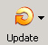
- Click the Update icon on the Quicken toolbar.
- Uncheck all boxes → Update Now in the One Step Update Settings dialog.
- If an update is available, Quicken will provide a description of the update and brief instructions for receiving the update.
- When the update is completed, close Quicken. Reopen Quicken.

GET YOU LATEST TRANSACTIONS


- Log in to your financial institution’s Web site, if available. Download your transactions into Quicken.
- Once the transactions are downloaded, accept all the transactions into your Quicken account register.
- Repeat this step for each account (such as checking, savings, credit cards, and brokerage) that you use for online banking or investing.
Note: You may not be able to download these transactions after the conversion.
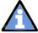
Important: You will not be able to proceed to the next section until you accept all transactions in the Downloaded Transactions tab.

DEACTIVATE YOUR ACCOUNT FROM WEB CONNECT

- Right click the account in the Quicken Account List

- Select Edit Account from pop-up.

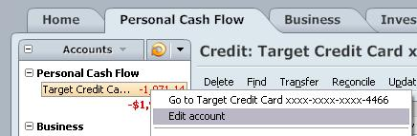

- Click the Online Services tab → click the Remove Connection button
.

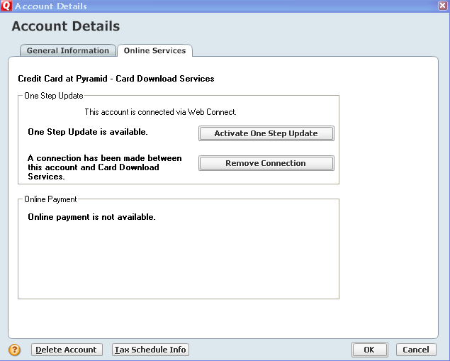

- Quicken will prompt you to confirm deactivation → click Yes → click ok

ACTIVATE WEB CONNECT

- Login to your FI website from an external browser to initiate a download of a Web Connect file into Quicken (.QFX). When presented with the screen below, choose the "Use an existing Quicken account" radio button

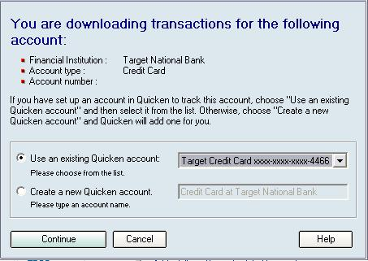
NOTE: Now the account will be connected via Web Connect. Quicken may prompt to activate One Step Update after a successful Web Connect download. Please select No do not activate and check the box to not be prompted again. Screen shot on the next page.
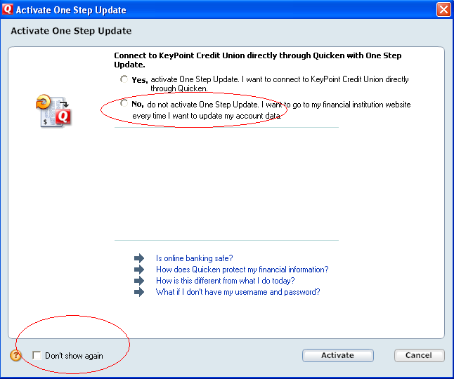

Thank you for making these important changes!

